JHS 3-year pupil premium strategy

strategy statement
Pupil premium is funding to improve education outcomes for disadvantaged pupils in schools in England. Evidence shows that disadvantaged children generally face additional challenges in reaching their potential at school and often do not perform as well as other pupils.
The aim of the funding is to target the attainment gap between pupils from deprived backgrounds and their most affluent peers. This gap persists through all stages of education, including entry into higher education. As in previous years, we will continue to use the pupil premium to improve the attainment of our disadvantaged pupils. The disproportionately high impact of COVID-19 on the education of disadvantaged pupils makes this more important than ever.

Research shows that:
- The highest early achievers from deprived backgrounds are overtaken by lower achieving children from advantaged backgrounds by age seven;
- The gap widens further during secondary education and persists into higher education;
- The likelihood of a pupil eligible for Free School Meals achieving five or more GCSEs at 1*-C including English and Mathematics is less than one third of a non-Free School Meals pupil;
- A pupil from a non-deprived background is more than twice as likely to go on to study at university as their deprived peer.

This document details Jotmans Hall Primary School’s Pupil Premium strategy for the next 3 years (2022-2025).

The Pupil Premium Allocation is currently calculated on the number of pupils on roll in receipt of Scheme of Aid children and from 2012-13 the government also included the funding for any child attending who had ever been on the Scheme of Aid (Ever 6), Looked after Children and Service children on the date of the School Census. Following COVID19 school closures we have also received a Recovery Premium to be used alongside the pupil Premium funding.

How we identify the specific challenges faced by our disadvantaged and vulnerable pupils:
We continually assess the children, through a variety of methods, to understand the specific elements of their education that pupils are finding challenging. We also develop an understanding of any non-academic challenges that pupils are facing that are negatively affecting their education and impact their access to teaching, for example:
- attendance and levels of persistent absence
- behaviour incidences and exclusions data
- wellbeing, mental health and safeguarding concerns
- access to technology and educational materials
- high mobility

The impact of expenditure is evaluated in July each year, using end of year data and reported on our website and to the governing body.

Summary information
CURRENT PUPIL INFORMATION 2021-22
Total number of pupils: | 313 | Total pupil premium budget: | £65,326 +  £5,289 (Carry forward) +  £7,105 (Recovery Premium)
Number of pupils eligible for pupil premium: | 54 (17%) | Amount of pupil premium received per child: | £1,385

Cohort information
CHARACTERISTIC | NUMBER IN GROUP | PERCENTAGE OF GROUP
Boys | 162 | 52%
Girls | 149 | 48%
SEN support | 53 | 17%
EHC plan | 9 | 2.8%
EAL | 3 | 1%

Assessment data

eyfs
 | Pupils eligible for pupil premium (7 pupils) | All pupils |  | National average
Good level of development (GLD) | 42.9% | 61%
Reading | 71.4% | 73%
Writing | 42.9% | 71%
Number | 57.1% | 80%

year 1 phonics screEning check
Pupils eligible for pupil premium (4 pupils) | All pupils | National average
50% | 77% | 75%

End of ks1

 | Pupils eligible for pupil premium (3 pupils) | All Pupils
 | Pupils eligible for pupil premium (3 pupils) | School | National
% achieving expected standard or above in reading, writing and maths | 100% | 68%
% achieving expected standard in reading | 100% | 77% | 68%
% achieving expected standard in writing | 100% | 68% | 58%
% achieving expected standard in maths | 100% | 77% | 68%

End of ks2

 | Pupils eligible for pupil premium (6 pupils) | All Pupils
 | Pupils eligible for pupil premium (6 pupils) | School | National
% achieving expected standard or above in reading, writing and maths | 83% | 51% | 59%
% achieving expected standard in reading | 83% | 73% | 74%
% achieving expected standard in writing | 83% | 53% | 69%
% achieving expected standard in maths | 83% | 69% | 71%

OTHER DATA
 | 2021-22 | 2020-21
Attendance data – Not Pupil Premium | 93.28% | 96.91%
Attendance data – Pupil Premium | 88.47% | 93.16%

Our disadvantaged children do not lack talent or ability to make significant contributions to our society. But they sometimes lack opportunity.

Our work has highlighted four core elements to focus on, mirroring national research. The interrelated elements are:

- Relationships
- Metacognition and self-regulated learning
- Social, Emotional and Mental Health (SEMH)
- Language development and comprehension

‘Addressing Educational Disadvantage in Schools and Colleges – The Essex Way’
Edited by Marc Rowland
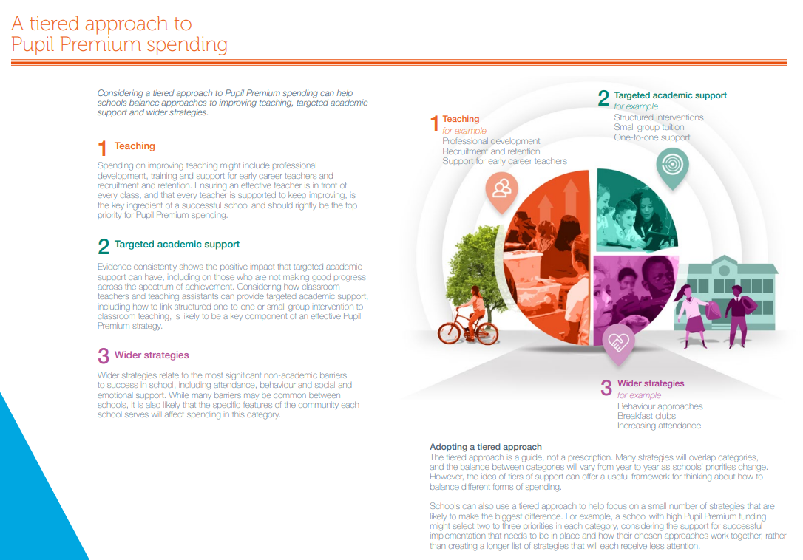
From The EEF Guide to The Pupil Premium

LONG-TERM PLAN (3-YEAR TIMESCALE):
Improving quality of teaching – metacognition and self-regulation

Education Endowment Foundation Toolkit: Behaviour interventions - Closing the disadvantage gap
According to figures from the Department for Education, pupils who receive Free School Meals are more likely to receive a permanent or fixed period exclusion compared to those who do not.
The most common reason for exclusion is persistent disruptive behaviour. Pupil behaviour will have multiple influences, some of which teachers can directly manage though universal or classroom management approaches. Some pupils will require more specialist support to help manage their self-regulation or social and emotional skills.

Rapid and sustained progress made in reading and phonics for all pupils, including disadvantaged and SEND.

Education Endowment Foundation Toolkit: Phonics - Closing the disadvantage gap
Studies in England have shown that pupils eligible for free school meals typically receive similar or slightly greater benefit from phonics interventions and approaches. This is likely to be due to the explicit nature of the instruction and the intensive support provided.
It is possible that some disadvantaged pupils may not develop phonological awareness at the same rate as other pupils, having been exposed to fewer words spoken and books read in the home. Targeted phonics interventions may therefore improve decoding skills more quickly for pupils who have experienced these barriers to learning.

Developing a robust pastoral support system within the school, including developing the Behaviour Management System to ensure consistency in approach across all staff.

Education Endowment Foundation Toolkit: Metacognition & Self-Regulation - Closing the disadvantage gap
There is some evidence to suggest that disadvantaged pupils are less likely to use metacognitive and self-regulatory strategies without being explicitly taught these strategies. Explicit teaching of metacognitive and self-regulatory strategies could therefore encourage such pupils to practise and use these skills more frequently in the future. With explicit teaching and feedback, pupils are more likely to use these strategies independently and habitually, enabling them to manage their own learning and overcome challenges themselves in the future.

Individually tailored strategies to support disadvantaged children with specific challenges

DfE Pupil Premium Guidance: September 2021 - Wider approaches
Support for non-academic issues that impact success in school, such as attendance, behaviour and social and emotional challenges. For example:
- school breakfast clubs
- counselling to support emotional health and wellbeing
- help with the cost of educational trips or visits

priority 1
Improving quality of teaching – metacognition and self-regulation

Member of staff responsible: Sarah Warnes
Objectives | Success criteria | Actions to be taken | Research evidence basis | By whom | By when | Resources needed | Progress indicators
1.Investigate training for staff on metacognition | All teaching staff are able to access training | Training to be sourced and booked | Education Endowment Foundation | SW | September 2022 | Money  Time | SLT minutes  Governor report
Progress | Achieved
2.Teachers are able to teach metacognitive skills | Metacognition techniques are used in all classrooms, consistently. | Teaching staff to participate in training. Teaching staff are able to transfer training into the classroom | Education Endowment Foundation  Addressing Educational Disadvantage in schools and colleges – The Essex Way | SW  Teaching Staff | Spring 2023 | Time | Classroom observations  SLT minutes  Governor report
Progress | Started
3. Children are able to use metacognitive skills to improve their learning. | Observations of children show skills being used independently. | Teaching staff are modelling techniques | Education Endowment Foundation  Addressing Educational Disadvantage in schools and colleges – The Essex Way | SW  Teaching Staff | 2022 - 23 | Time | Observations  Pupil Voice
Progress | Not started

PRIORITY 2
Rapid and sustained progress made in reading and phonics for all pupils, including disadvantaged and SEND.

Member of staff responsible: Fiona Ward, Becky Chapman, Gemma Hindes
Objectives | Success criteria | Actions to be taken | Research evidence basis | By whom | By when | Resources needed | Progress indicators
1. All children make progress towards the phonics test. | School data is in-line or above National Average | Regular Phonics screening and gaps assessment to identify children in need of extra support. Intervention sessions to take place in Yr 1 & 2 | Education Endowment Foundation | BC | Assessment points September, February, June each year. | LSA time  Teacher time  SLT time | School data is tracked each year at assessment points.
Progress | Achieved
2. Groups of children not at expected level in Reading & phonics are quickly identified. | Children close the gap and make above expected progress | Children identified on inclusion grids and interventions in place. | Education Endowment Foundation | BC/FW/GH  Class teachers | Assessment points September, February, June each year. | LSA time  Teacher time  SLT time | School data  Staff meetings  SLT minutes  Governor reports
Progress | Achieved
3. New developments in phonics are known | The school is using approved resources | New resources are purchased | DfE | BC/SW | Ongoing | SLT Time  Money | SLT minutes  Governor reports
Progress | Achieved
4. Additional reading sessions given to all PP pupils | PP children achieve in-line with non-PP | Teaching Staff to plan in additional sessions each week. | DfE | Class teachers | Ongoing | LSA time  Teacher time | Observations  Pupils Voice
Progress | Ongoing

PRIORITY 3
Developing a robust pastoral support system within the school, including developing the Behaviour Management System to ensure consistency in approach across all staff.

Member of staff responsible: Sarah Warnes
Objectives | Success criteria | Actions to be taken | Research evidence basis | By whom | By when | Resources needed | Progress indicators
1.Investigate training for staff on behaviour management strategies | All teaching staff are able to access training | Training to be sourced and booked | Education Endowment Foundation | SW | January 2022 | Money  Time | SLT minutes  Governor report
Progress | Achieved
2.Staff are able to implement behaviour management strategies | Behaviour management strategies are used in all classrooms, consistently. | Teaching staff to participate in training.  Teaching staff are able to transfer training into the classroom | Education Endowment Foundation  Addressing Educational Disadvantage in schools and colleges – The Essex Way | SW  Teaching Staff | Spring 2022 | Time | Classroom observations  SLT minutes  Governor report
Progress | Not started
3.Behaviour Policy is updated in line with behaviour management strategies | Policy approved by governors and on school website | Draft document to go to full governing body | Education Endowment Foundation  Addressing Educational Disadvantage in schools and colleges – The Essex Way | BC/GH | Summer 2022 | SLT Time | Governor minutes
Progress | Achieved
4. Behaviour is managed within the classroom | Number of serious behaviour incident is reduced (less SLT involvement) | Analysis to be carried out by behaviour managers | Education Endowment Foundation  Addressing Educational Disadvantage in schools and colleges – The Essex Way | BC/GH | Autumn 2022 | SLT Time | Governor report
Progress | Started
5. Engage in Mental Health Support Teams programme | MHST delivers evidence-based interventions to children and their parents/carers. | Initial meeting29th September 2021 | Addressing Educational Disadvantage in schools and colleges – The Essex Way | SW/GH | October 2022 | SLT Time | SLT minutes  Governor report
Progress | Achieved

PRIORITY 4
Individually tailored strategies to support disadvantaged children with specific challenges

Member of staff responsible: SLT (SW, CF, EN, BC, FW, GH)
Objectives | Success criteria | Actions to be taken | Research evidence basis | By whom | By when | Resources needed | Progress indicators
1. All PP families are aware of additional support offered by the school | PP pupils are accessing school trips, music lessons, extra-curricular clubs | PP leaflet to parents to be updated and issued | Education Endowment Foundation  DfE | SW | October 2021 | Time  Money | SLT minutes  Governor report
Progress | Achieved
2. Individual family’s needs are addressed in a timely fashion. | PP pupils do not face a barrier to learning in the classroom through lack of resources. | Class teachers to be told to report any concerns to SLT  SLT to follow up with the family to discuss support | Education Endowment Foundation  DfE | Class teachers  SLT | Ongoing | Time  Money for resources | SLT minutes  PP report
Progress | Achieved
2. Individual pupil’s SEMH needs are addressed in a timely fashion. | PP pupils do not face a barrier to learning in the classroom due SEMH. | Class teachers to be told to report any concerns to SLT  SLT to follow up with the family to discuss support | Education Endowment Foundation  DfE | Class teachers  SLT | Ongoing | Time  BATIC counselling | SLT minutes  PP report
Progress | Achieved

Research

https://www.gov.uk/government/publications/pupil-premium/pupil-premium

https://educationendowmentfoundation.org.uk/support-for-schools/bitesize-support/pupil-premium-guide
https://educationendowmentfoundation.org.uk/guidance-for-teachers/using-pupil-premium

https://educationendowmentfoundation.org.uk/education-evidence/teaching-learning-toolkit/metacognition-and-self-regulation
https://educationendowmentfoundation.org.uk/education-evidence/teaching-learning-toolkit/phonics
https://educationendowmentfoundation.org.uk/education-evidence/teaching-learning-toolkit/behaviour-interventions

Book: Addressing Educational Disadvantage in schools and colleges – The Essex Way (ISBN:978 1 913622 45 9)

https://schools.essex.gov.uk/pupils/pupil-premium/Documents/Toolkit.pdf

